 | Sinhgad Technical Education Society’s  RMD Sinhgad School of Engineering, Warje, Pune.  Department of E&TC Engineering

Name of Student | Aditya Ravindra Ghayal
Division | A
Roll Number | 23
Experiment Title | Power vs RMS Delay spread
Marks

 |  | Sinhgad Technical Education Society’s  RMD Sinhgad School of Engineering, Warje, Pune.  Department of E&TC Engineering | Expt.No.  3
Title |  | Power vs RMS Delay spread

Aim
Compute the RMS delay spread for a given Power profile and plot the graph of Power vs Delay.

Apparatus
PC, Octave

Theory
In radio systems with low antenna heights, there are often multiple indirect paths between the transmitter and receiver due to reflections from surrounding objects, in addition to the direct path when there is line-of-sight. Such multipath propagation is particularly significant in urban environments, where the sides of buildings and paved road surfaces provide strong reflections. As a result, the received signal consists of the summation of several components having various amplitudes, phase angles and directions of arrival.
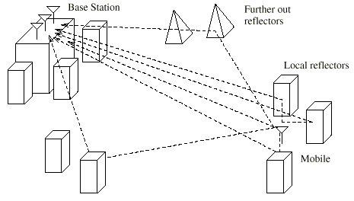
Figure: Illustration of reflections of various kinds
The resulting spatial variability of signal strength can be viewed as having two regimes:
a) rapid fading which varies over distances of the order of a wavelength due primarily to changes in phase angles of different signal components.
b) slow fading which varies over larger distances due primarily to changes in shadowing loss by surrounding objects.
In addition, the various signal components can be Doppler shifted by different amounts due to the movement of the mobile or of reflecting objects such as vehicles.
The multipath mobile channel can be characterized in terms of its impulse response which varies at a rate dependent on the speed of the mobile and/or the scatterers. Therefore, a receiver has to be able to cope with the signal distortion arising from echoes in the channel as well as the rapid changes in the nature of this distortion. Such characteristics of the mobile radio channel are described by the power delay profiles and the Doppler spectra which are obtained from wideband channel sounding measurements.

Delay Spread
As an electromagnetic wave can travel from the transmitter to the receiver via multiple paths, the signal can reach the receiver with interference from its own echoes. Delay spread measures the effect of the time dispersion in multipath channels. Thus, the total power received in a multipath wireless channel occurs over a spread of time referred to as the delay spread.
Figure shows how a transmitted pulse its received at the receiver with different signal strength as it travels through a multipath channel with different propagation delays (τ, τ1, τ2).
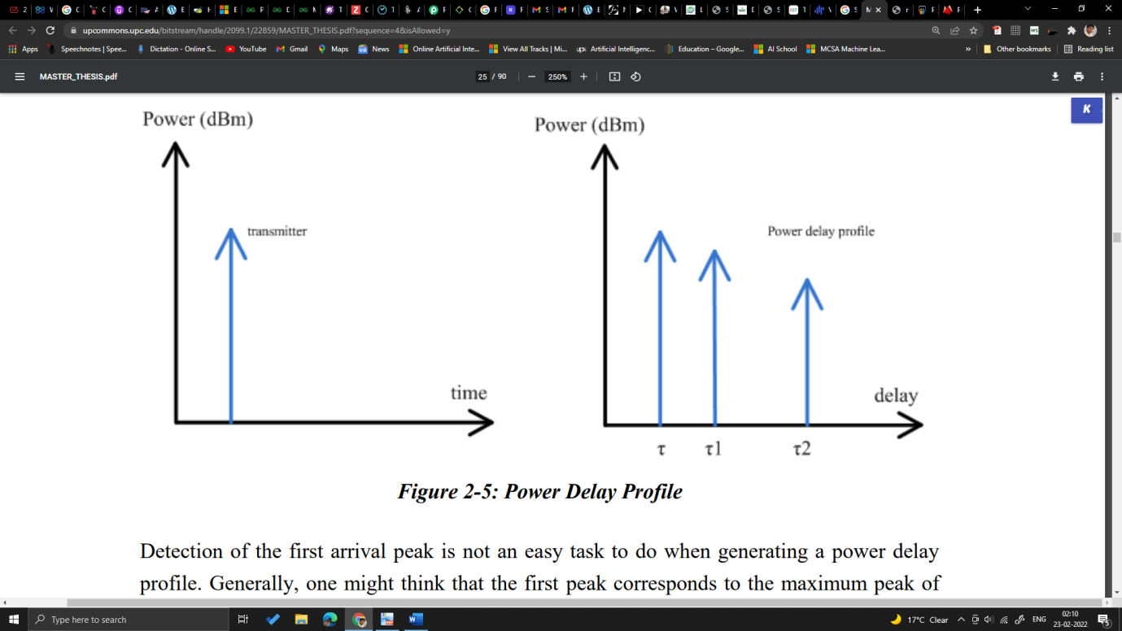
Figure: Power Delay Profile Example 1
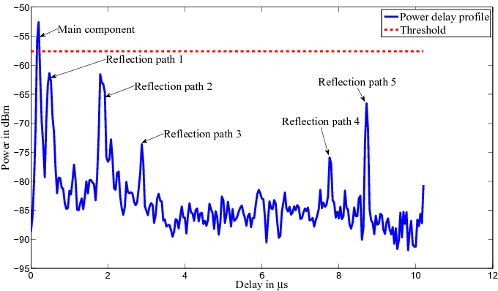
Figure: Power Delay Profile Example 2
Detection of the first arrival peak is not an easy task to do when generating a power delay profile. Generally, one might think that the first peak corresponds to the maximum peak of the signal, but this is not necessarily the case. It may be that the peak of maximum energy is not the first peak, as this can suffer greater attenuation than other arrivals in Non-Line of Sight (NLOS) situations.
Power Delay Profile is usually supplied as a table of values obtained from empirical data and it serves as a guidance to system design. Nevertheless, it is not an accurate representation of the real environment in which the mobile is destined to operate at.
Power delay profile is a good representation of the average “geometry” of the transmitter, the receiver, and the reflectors. To quantify “how spread-out” the arriving signals are, we use time dispersion parameters:
Excess delay: the delay with respect to the first arriving signal ($τ$)
Maximum excess delay: the excess delay of the latest arriving Multi Path Component (MPC)
Mean excess delay: the “mean” excess delay of all arriving MPC
RMS delay spread: the “standard deviation” of the excess delay of all arriving MPC
In a nutshell, the RMS delay spread indicates the capability of the communication channel of supporting high data rate communications by implying the probability of performance degradation which may occur due to the ISI because of multipath signal propagation.
Even though a same signal is transmitted from single transmission antenna, the signal may go through various different path. Each of the different path may cause different travel distance if the signal get reflected by one or more obstacles (like buildings) and in some case different path may has different physical property of propagation media, so it is highly likely that the signal traveling through different path would arrive at the receiver antenna at different timing. So if you send a signal from a transmitter antenna and measure the arrival time at the receiver antenna which is a certain distance away from the transmitter antenna, you would get multiple different arrival timing.
If you plot those arrival timing on the axis of time, you would see a certain variation (spread) of those values. This spread is called 'Delay Spread'.
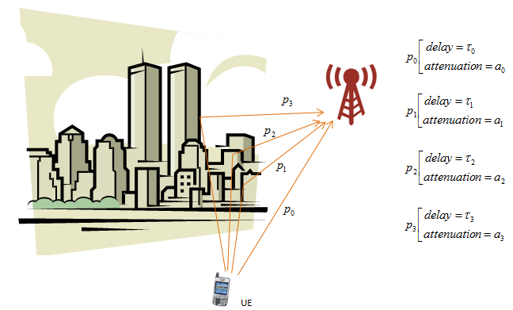
If I plot the signals detected by a receiver antenna in time vs amplitude plot, it can be represented as follows. As you see here, you will see multiple copies of the same signal coming in with different timing and different amplitude. Using these time variation and amplitude variation, we can define several different criteria (metrics) to define the nature of the channel. To introduce these criteria (metric) is the main purpose of this page.
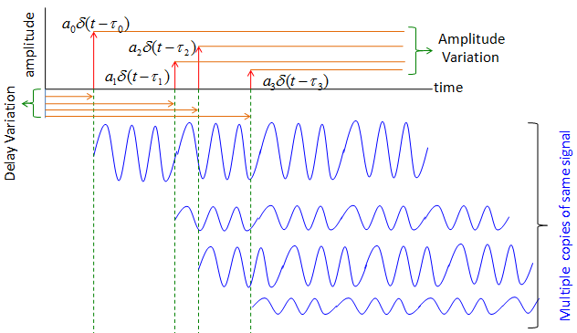

Max Delay Spread
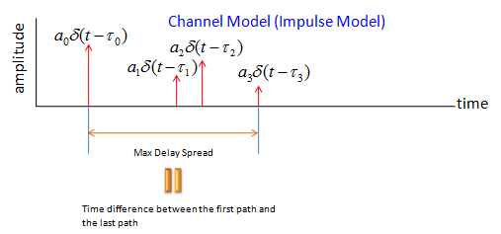

Problems with Max Delay Spread
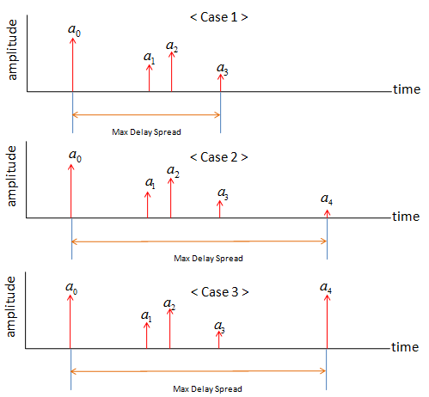

Average Delay Spread

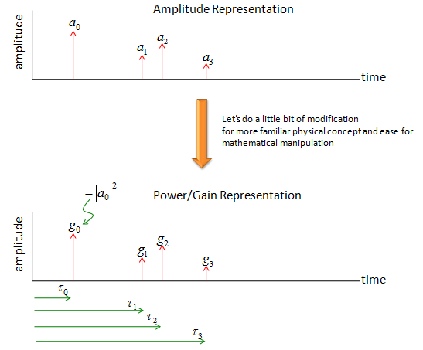
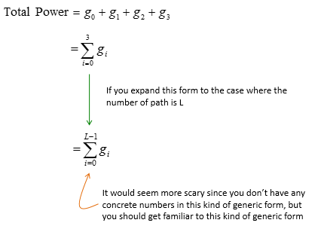
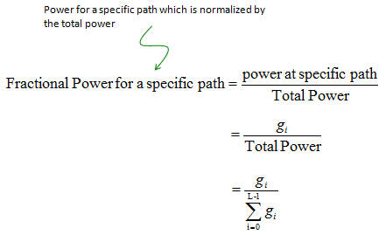
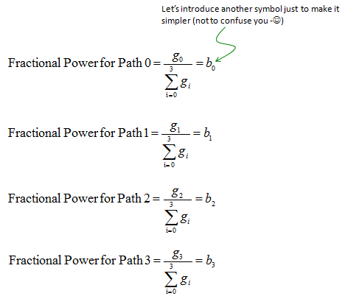
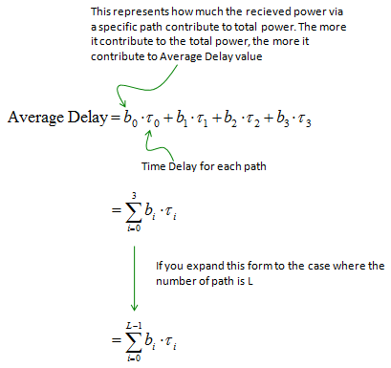

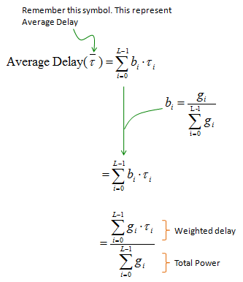

RMS Delay Spread
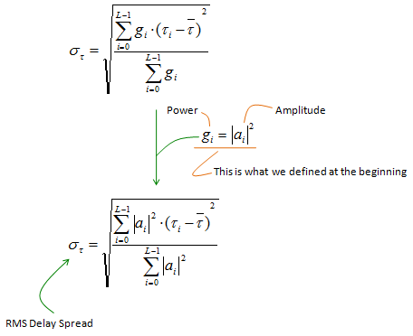

Power delay proﬁle
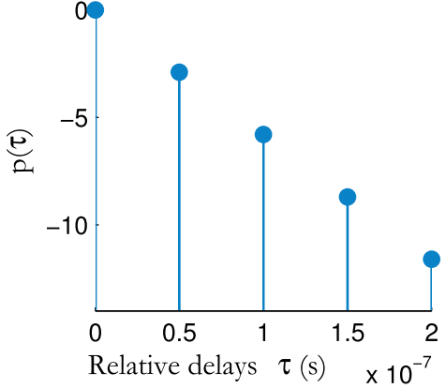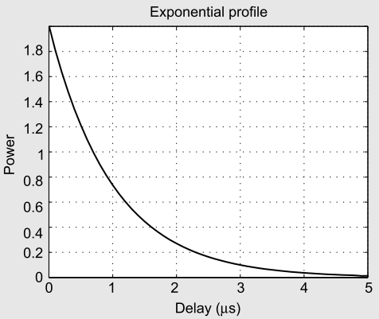
Figure: (1) Discrete PDP (2) Continuous/exponential PDP
For continuous PDP, the RMS delay spread (τrms) can be calculated as
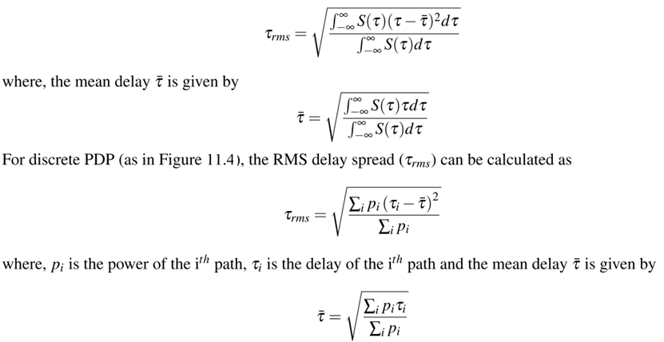
Knowledge of the delay spread is essential in system design for determining the trade-off between the symbol rate of the system and the complexity of the equalizers at the receiver. The ratio of RMS delay spread (τrms) and symbol time duration (Tsym ) quantiﬁes the strength of intersymbol interference (ISI). Typically, when the symbol time period is greater than 10 times the RMS delay spread, no ISI equalizer is needed in the receiver. The RMS delay spread obtained from the PDP must be compared with the symbol duration to arrive at this conclusion.
With the power delay proﬁle, one can classify a multipath channel into frequency selective or frequency non-selective category. The derived parameter, namely, the maximum excess delay together with the symbol time of each transmitted symbol, can be used to classify the channel into frequency selective or non-selective channel.
PDP can be used to estimate the average power of a multipath channel, measured from the ﬁrst signal that strikes the receiver to the last signal whose power level is above certain threshold. This threshold is chosen based on receiver design speciﬁcation and is dependent on receiver sensitivity and noise ﬂoor at the receiver.
Maximum excess delay, also called maximum delay spread, denoted as (Tm), is the relative time difference between the ﬁrst signal component arriving at the receiver to the last component whose power level is above some threshold. Maximum delay spread (Tm) and the symbol time period (Tsym) can be used to classify a channel into frequency selective or non-selective category. This classiﬁcation can also be done using coherence bandwidth (a derived parameter from spaced frequency correlation function which in turn is the frequency domain representation of power delay proﬁle).
A channel is classiﬁed as frequency selective, if the maximum excess delay is greater than the symbol time period, i.e, Tm >Tsym . This introduces intersymbol interference into the signal that is being transmitted, thereby distorting it. This occurs since the signal components (whose powers are above either a threshold or the maximum excess delay), due to multipath, extend beyond the symbol time. Intersymbol interference can be mitigated at the receiver by an equalizer.
On the other hand, if the maximum excess delay is less than the symbol time period, i.e, Tm <Tsym , the channel is classiﬁed as frequency non-selective or zero-mean channel. Here, all the scattered signal components (whose powers are above either a speciﬁed threshold or the maximum excess delay) due to the multipath, arrive at the receiver within the symbol time. This will not introduce any ISI, but the received signal is distorted due to inherent channel effects like SNR condition. Equalizers in the receiver are not needed.

 | Sinhgad Technical Education Society’s  RMD Sinhgad School of Engineering, Warje, Pune.  Department of E&TC Engineering | Expt.No.  3
Title | Power delay profile
 | Student Worksheet

Problem Statement
Consider the average power proﬁle $ϕ\left(τ\right)=αe^{-τ/β}$ where $α=3 dB, β=1μs$. Compute the RMS delay spread $σ_{τ}^{RMS}$ for this proﬁle.

Formulae
$$Mean delay, \overline{τ}=\frac{\int_{-∞}^{∞}{ϕ\left(τ\right) τ dτ}}{\int_{-∞}^{∞}{ϕ\left(τ\right) dτ}}$$
$$RMS delay, σ_{τ}^{RMS}=\sqrt{\frac{\int_{-∞}^{∞}{ϕ\left(τ\right){\left(τ-\overline{τ}\right)}^{2}dτ}}{\int_{-∞}^{∞}{ϕ\left(τ\right)dτ}}} \\ maximum symbol rate to avoid ISI=\frac{1}{10×σ_{τ}^{RMS}}$$
$$For 0.9 correlation, Coherance BW=\frac{1}{50×σ_{τ}^{RMS}}$$

Conclusion
A transmitted pulse gets received at the receiver with different signal strengths as it travels through a multipath channel with different propagation delays. Depending on the nature of the transmitted signal with respect to characteristics of channel, the fading channels can be classiﬁed based on effects due to multipath delay spread and the Doppler spread. Multipath delay spread, characterized by power delay proﬁle, leads to time dispersion and frequency-selective fading.

Review Questions
- What is the difference between large scale and small scale propagation model?
- Calculate the mean excess delay, rms delay spread, and the maximum excess delay (10 dB) for the multipath profile given in the figure below. Estimate the 50% coherence bandwidth of the channel. Would this channel be suitable for AMPS or GSM service without the use of an equalizer? (Refer: Example 4.4, Wireless Communications, Principles and Practice, Rappaport)
For Q.2 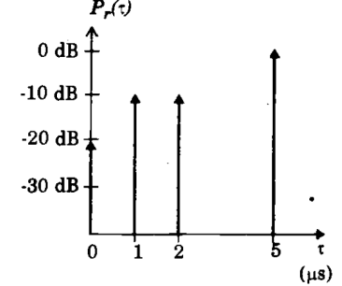 For Q.3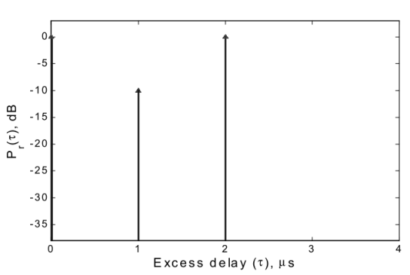
- A local spatial average of power delay profile is shown in figure,
  - Determine the RMS delay spread and mean excess delay for the channel.
  - Determine the maximum excess delay (-20 dB)
  - Determine the maximum RF symbol rate if the symbol duration $T$is less than $10σ$, where $σ$ is RMS delay spread, an ISI takes place.
  - If the mobile travelling at 30 Km/hr receives a signal through the channel, determine the time over which the channel appears stationary. Refer: http://www.comlab.hut.fi/opetus/227/2002/s5.pdf
- What is the significance of rms delay spread explain?

 | Sinhgad Technical Education Society’s  RMD Sinhgad School of Engineering, Warje, Pune.  Department of E&TC Engineering | Expt.No.  3
Title | Power delay profile
Name
Roll No.

Program
Consider,
$$moment_1=\int_{-∞}^{∞}{ϕ\left(τ\right) τ dτ} \\ moment_2 =\int_{-∞}^{∞}{ϕ\left(τ\right){\left(τ-\overline{τ}\right)}^{2}dτ}$$
Define new function, FileNew Functionmeas_continuous_PDP
- function[meanDelay,rmsDelay,symbolRate,coherenceBW]=meas_continuous_PDP(fun,lowerLim,upperLim)
- %FunctiontocalculatemeanDelay,RMSdelayspread,maximumsymbol
- %ratethatasignalcanbetransmittedwithoutISIandthecoherence
- %BWforthePDPequationspecifiedasfunctionhandle(fun)
- %example:fun=@(tau)exp(-tau/0.00001);%givenPDPequation
- %lowerLim-lowerlimitforintegration
- %upperLim-upperlimitforintegration
- moment_1=@(x)x.*fun(x);
- meanDelay=integral(moment_1,lowerLim,upperLim)/integral(fun,lowerLim,upperLim);
- moment_2=@(y)((y-meanDelay).ˆ2).*fun(y);
- rmsDelay=sqrt(integral(moment_2,lowerLim,upperLim)/integral(fun,lowerLim,upperLim));
- symbolRate=1/(10*rmsDelay);%maximumsymbolratetoavoidISI
- coherenceBW=1/(50*rmsDelay);%for0.9correlation
- %coherenceBW=1/(5*rmsDelay);%for0.5correlation
- Endfunction
Run following script after saving above function in a file.
- fun = @(tau)2*exp(-tau/1e-6);
- [meanDelay,rmsDelay,symbolRate,coherenceBW] = meas_continuous_PDP(fun,0,10e-6);
- tau = [0:0.01e-6:5e-6];
- fun1 = 2*exp(-tau/1e-6);
- plot (tau, fun1, 'r', 'LineWidth', 2);
- title ('Power vs Delay', 'Fontsize',20);
- xlabel ('Delay', 'Fontsize',16);
- ylabel('Power(dBm)', 'Fontsize',16);

Output
